FBWF System Console Using Instruction V1.1

FBWF System Console is used to protect the Windows system files from being defected & avoid blue screen problem and network error & protect the Windows system.
- After you install the new Windows XP, FBWF system console would be on as default.
- When you would like to install a printer driver or change the resolution of the LCD screen, first you need to close FBWF system console, and then restart the instrument to install a printer driver or change the resolution of the LCD screen.
- Please check the following procedure to close FBWF system console & restart the instrument.
(1). Double click the icon of FBWF system console as figure 1
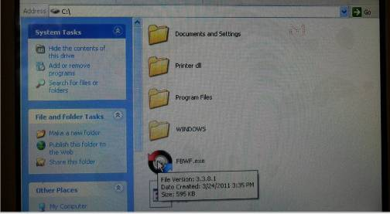
Figure 1
(2). Input the password “1008” & click the “OK” button as figure 2, and then you will find figure 3 showed on the instrument.
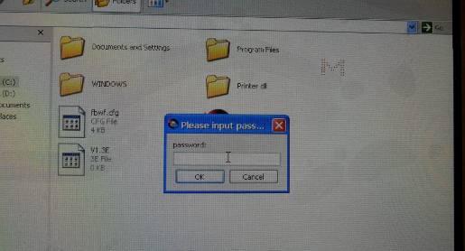
Figure 2
(3). Click the button as figure 3 to close FBWF system console, and then the instrument will remind you that you need to restart the instrument as figure 4. You need to click “OK” as figure 4 & click the button as figure 5 to restart the instrument. After you restart the instrument, you can install a printer driver or change the resolution of the LCD screen.
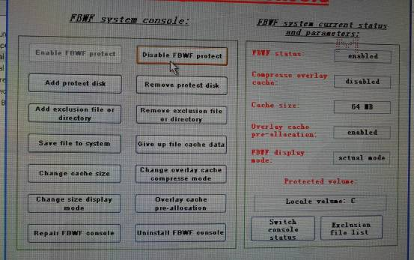

Click this button
Figure 3
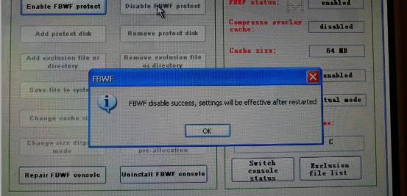
Click “OK”

Figure 4
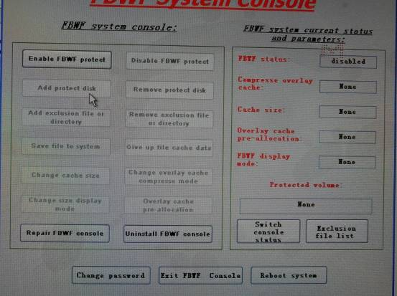

Click this button restart the instrument
Figure 5
- After you install a printer driver or change the resolution of the LCD screen, please check the following procedures to open FBWF system console again.
(1). Please click the button as figure 6, and then the instrument will remind you that you need to restart the instrument as figure 7.
Click this button
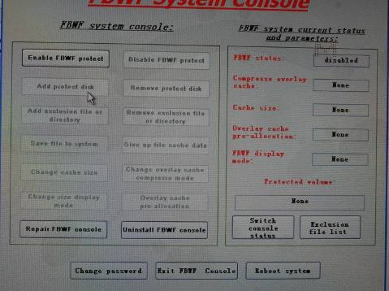

Figure 6

Click this button
Figure 7
Click this button restart the instrument

Figure 8
(2). You need to click “OK” as figure 7 & click the button as figure 8 to restart the instrument. After you restart the instrument, FBWF system console is opened again.

